A Thumbnail History:
This essay gives a very brief overview of the history of what is known today as the Gibsonville United Methodist Church . Other documents (under the "Detailed History" tab) will discuss historically important people and events in much greater detail. These significant events may be more easily understood or appreciated in the historical framework described here.
The word “church” can be used to refer to a denomination, a congregation, or a building. I found it important to examine and trace all three over time.
Historical Context – The Methodist Church
To fully understand the history of the Gibsonville United Methodist Church , one must understand the historical (religious, organizational, social, and political) context in which the church has existed.
Establishment of the Methodist Denomination
Methodism was founded by John Wesley in the middle of the eighteenth century. He attended Oxford University and was ordained a minister of the Church of England. While at Oxford , he and others created a group devoted to scholarly goals, to prayer, and to helping the less fortunate. The members of this group were often referred to as "Methodists" by their classmates as a because of the methodical way they went about their religious business. John Wesley founded Methodism within the Anglican Church in 1739. Methodism spread and became its own separate denomination in 1744.
Methodist Church in North America
Early American Methodism began when Methodist immigrants traveled to the North American colonies and took the initiative to organize the religion in their new homeland in the 1760's. In 1773, the Methodists held their first conference during which they established groundwork for future church organization and agreed to continue to abide by John Wesley's teachings. Soon Methodist churches were calling themselves the Methodist Episcopal Church – the word “Episcopal” meaning “advocating church government by bishops.”
After the American Revolution of 1776 and the American political independence from England , Wesley felt it necessary to allow the Americans religious independence as well, so the American Methodist movement began to function separately from the English Methodist movement.
The Methodist Episcopal Church was the parent church, directly descended from the organization at Baltimore in 1784. Even with all its losses by withdrawal, expulsion, secession, separation, and division, it occupied first place in the number of Annual Conferences, ministers, churches and members, Sunday schools, officers and teachers, and scholars.
Schisms, Splits in the Methodist Episcopal (ME) Church
Denominations spun off from the main stream Methodist denominations for reasons ranging from language (German-speaking United Brethren in Christ in 1800) to slavery (African Methodist Episcopal Church in 1816) to episcopacy (Methodist Protestant Church in 1830).

United Brethren in Christ
Many German-speaking churches (including some in Methodist Episcopal Churches) in Pennsylvania , Virginia , Maryland , and Ohio felt need for organization and as a way to renew the faith of German-speaking settlers in America . In 1800, they began holding a yearly conference for business and inspiration. Just thirteen ministers attended the first conference, which was held in a private home. But they accomplished two major things:
- Adopted a name: United Brethren in Christ.
- Elected Martin Boehm (a Mennonite) and Philip William Otterbein (a Methodist) as bishops.
The United Brethren church has the claims to be the first denomination to actually begin in the United States , not as a transplant from Europe . The United Brethren church was truly “made in America .”
Much later, in 1946, the Evangelical United Brethren Church was formed in by the merger of The Church of the United Brethren in Christ and the Evangelical Church .

Methodist Protestant Church
In 1828, a division occurred resulting in the formation of the " Methodist Protestant Church ." This new denomination came about when dissention erupted over issues of lay representation to the Annual and General Conferences and the reduction of the bishop's powers and electing presiding elders. The absolute stationing power and the appointment of presiding elders by the bishop had been points of contention from the beginning of Methodism. Lay representation was, however, a new idea. The ministers and laymen alike, who were strong advocates of reforms, were suspended or expelled from the Methodist Episcopal Church. Some voluntarily withdrew, seeing no hope of their reforms becoming reality, and a new denomination, the Methodist Protestant Church , was organized in 1830.
The Methodist Protestant Church had neither bishops nor presiding elders, only presidents of each Annual Conference who continued to serve as pastors. A Committee made appointments of preachers that were then approved by the Conference. Lay representatives were elected to Annual and General Conferences. Each president of the General Conference served as superintendent for four years.

Methodist Episcopal Church, South
By the 1840s, slavery was the foremost political and social issue in American society. In the Methodist Episcopal Church, the issue came to a head in 1844 when a Bishop married a woman who owned slaves, which precipitated heated debate at the General Conference over the propriety of a direct Episcopal connection to slaveholding. The northern majority demanded that the bishop resign, and that led to an impasse with the southern conferences. The final result was a Plan of Separation which provided for two Methodist Episcopal Churches, North and South. Delegates from the southern conferences met at a Convention at the Fourth Street Church in Louisville, Kentucky , in1845 and organized the Methodist Episcopal Church, South.
From the time of the Revolution until the beginning of the Civil War, the Methodist movement was the most rapidly growing movement of its kind. By this time the Methodist Episcopal Church was the largest denomination in the United States , and its division was to many observers an omen of what could happen to the nation as well as to other churches.
Reunification of the Methodist Church
The separation of three major segments of Methodism lasted until 1939, when the Methodist Episcopal Church, the Methodist Episcopal Church, South, and the Methodist Protestant Church merged to form The Methodist Church.
United Methodist Church
In 1968, the Evangelical United Brethren Church, a descendant of the German-speaking 1815 spin-off United Brethren in Christ Church rejoined the mainstream Methodist Church to form the United Methodist Church. In many ways, the Methodist Church has gone full circle – founded in England , migrated to North America, split into different segments, and then rejoined to form the United Methodist Church .
Political Perspective – The Town of Gibsonville
A community named for a local landowner, Joseph Gibson, formed in central North Carolina and a Post Office bore the name of “Gibsonville” as early as 1855. The “Town of Gibsonville ” was chartered by the North Carolina General Assembly in 1871. The town grew and prospered, being situated on two major east-west thoroughfares, the North Carolina Railroad and highway 10, one of the first numbered and macadam roads in the state.
In 1880, with Berry Davidson as partner, John Q. Gant entered the cotton mill business, opening Altamahaw Cotton Mills. In 1884, the Holt brothers bought out Davidson's interest. In 1887, Mr. Berry Davidson built the original cotton mill located in Gibsonville, the location being chosen for it access to the railroad. Although it was later sold to Cone Mills, the facility remained the economic engine that drove the Town of Gibsonville which prospered and grew. Mr. Berry Davidson and his son, Mr. D. M. Davidson, were deeply involved in the politics of the town, both serving as Mayor, leading in making the Town of Gibsonville grow to be a respectable place in which to live, work, and worship.
Railroad passenger service to Gibsonville was terminated and highway US70 was built in 1931 replacing highway 10 as the east-west thoroughfare and passing well south of town, making Gibsonville an out-of-the-way place. The Cone Mills continued to function on a much reduced scale until it finally closed. The Town of Gibsonville ’s growth slowed considerably.
Today because of overall population growth in the area, Gibsonville is growing and expanding as a “bedroom community” serving the surrounding cities of Burlington , Greensboro , and Elon as they expand. Once again, Gibsonville is a respectable place to live even though the mill remains closed. With Gibsonville's renewed growth, the Gibsonville United Methodist Church has also grown and prospered.
Gibsonville United Methodist Church
The Methodist Protestant Church , the first church in Gibsonville, was built under the leadership of Mr. Berry Davidson was completed in 1892. It occupied the building that is the First Baptist Church today (2006).
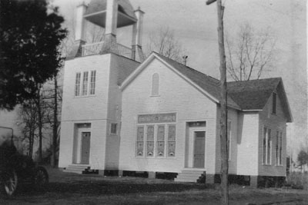
Methodist Protestant Church
Gibsonville, North Carolina
In 1907, the Methodist Episcopal Church, South was the third church to organize. Services were held in the Masonic Lodge, the Methodist Protestant Church , and finally in the old “ Green School Building ” until the new building was completed in 1911. It stood where the Gibsonville United Methodist Church stands today at the corner of Church and Joyner streets.
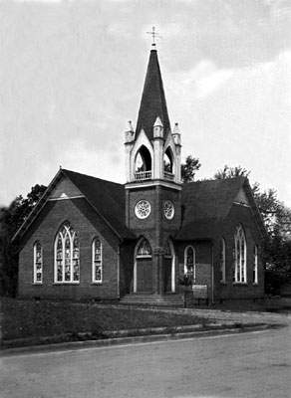  Methodist Episcopal Church, South  Gibsonville, North Carolina | 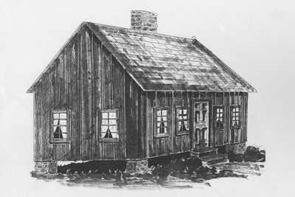  The Church Hut (1925 - 1950)  Drawn and photographed by Don Henderson  using specifications furnished by  Opal Ozment and Peggy Ray
So two Methodist congregations and churches existed in the small town of Gibsonville within a few hundred yards of each other.
Both congregations were too small to adequately sustain themselves. The Methodist Episcopal Church had so few members they could only afford to have “student” ministers (interns). And a disproportionate share of the financial support fell on a few of the families in the church. It was evident that one church or the other was going to have to close and combine the congregations. The congregation of the Methodist Protestant Church staunchly declined to move, so the congregation of the Methodist Episcopal voted at a Wednesday night prayer meeting to close the doors and move the few hundred yards to the Methodist Protestant Church. So in 1938, a year before the major segments of Methodism combined, the Gibsonville congregations merged.
The years following the merger were difficult. Issues that caused the separation initially still existed. The former Methodist Protestant congregation was larger, and the former Methodist Episcopal Church facilities were better and included a parsonage. With the assignment of the first preacher by the Conference of the newly combined Methodist Church , the congregations moved back the few hundred yards down to the church building that had formerly had been the Methodist Episcopal Church. There were influential families from both congregations including town merchants and the early mayors of Gibsonville. It became obvious very early that there was great ill-will between the constituents of the two Churches, and that the leadership in the ill-will was largely vested in two families which had managed to get the members, in general, to take sides. Despite the long-lasting differences, the combined congregations survived and even prospered and grew because of hard work and strong lay person effort to recruit families with children into the church.
The physical building that housed the Gibsonville Methodist Church also grew. The “hut” that housed the Sunday School was replaced in1950 with the Education Building .
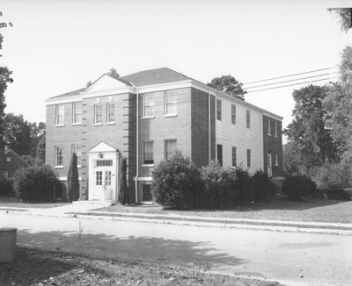
Education Building
Note the missing brick in anticipation
of the addition of the new sanctuary.
The sanctuary, which was in poor physical condition and too small for the growing congregation, was replaced in1962 with a new, modern sanctuary.
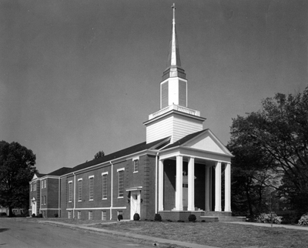
In 1968, with the rest of Methodism, it became the United Methodist Church . Beginning in 2002, the "Forward in Faith" and "Advancing in Faith" campaigns funded a major refurbishment of both the sanctuary and the Education Building . This resulted in the building that houses the Gibsonville United Methodist Church today (2009).
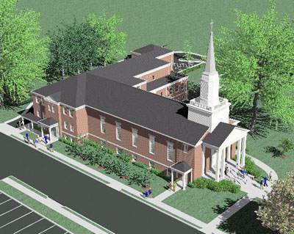
Gibsonville United Methodist Church
Gibsonville, North Carolina
During the refurbishment of the sanctuary, services were held in the Gibsonville Elementary School which replaced the “ Green School Building ” The bronze bell that rang out from the steeple of the old Methodist Episcopal Church is proudly displayed in front of the church, a physical tie to the historical church, both the building and the congregation.

