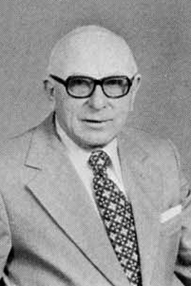  D. B. Alderman  Methodist  1959 - 1960 | 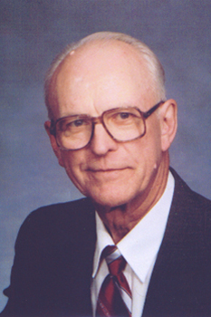  W. W. Blanton  Methodist  1964 - 1968 | 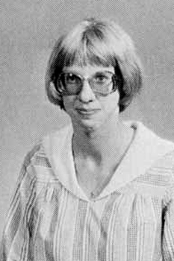  P. A. Blosser  United Methodist | 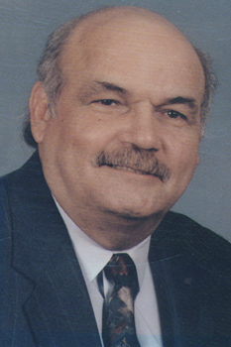  J. E. Bowen  United Methodist  1993 - 1996
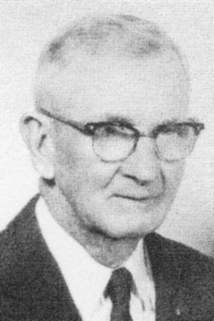  G. W. Clay  Methodist Episcopal  1921 - 1923 | 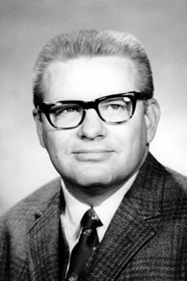  D. M. Cowart  United Methodist  1968 - 1973 | 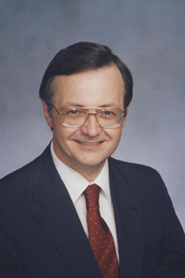  R. V. Dodd  United Methodist  1977 - 1983 | 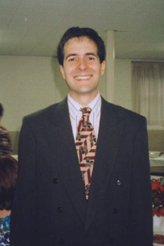  Edwardo  United Methodist
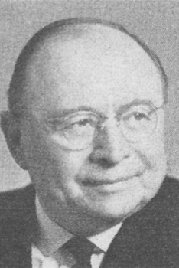  E. W. Fox  Methodist Episcopal  1912 | 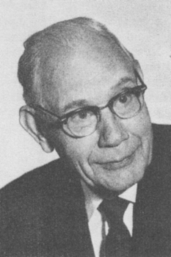  A. C. Gibbs  Methodist Episcopal  1916 | 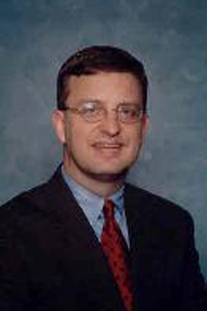  D. S. Greene  United Methodist  2002 - 2009 | 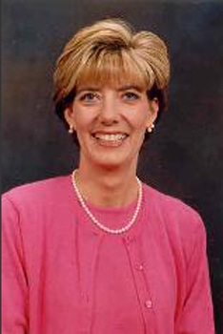  L. W. Greene  United Methodist  2002 - 2009
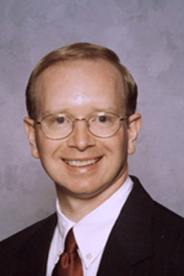  J. F. Howard  United Methodist  1998 - 2002 | 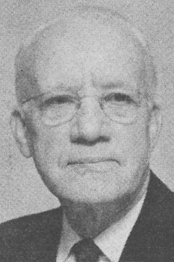  R. A. Hunter  Methodist  1943 - 1944 | 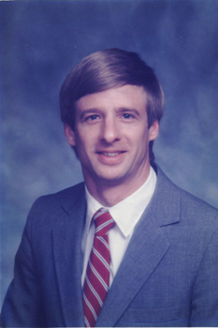  D. M. Jordan  United Methodist  1983 - 1989 | 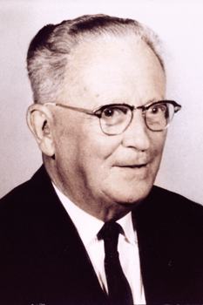  K. H. Koestline  Methodist  1955 - 1958
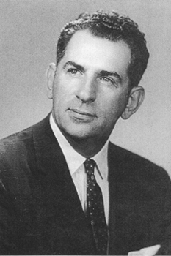  J. A. Lindsey  Methodist  1947 - 1951 | 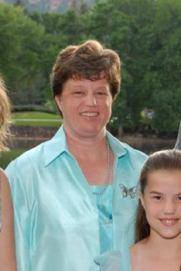  A. R. Marlowe  United Methodist  2009 - 2013 | 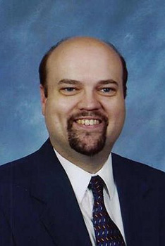  J. D. Marlowe  United Methodist  2009 - 2013 | 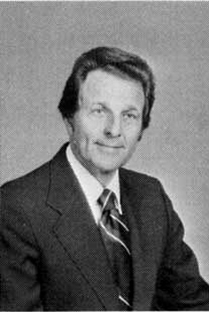J.  J. J. Miller  Methodist  1960 – 1964
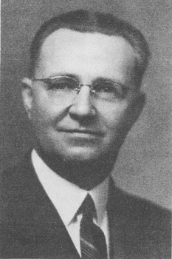  E. H. Nease  Methodist Episcopal  1924 - 1929 | 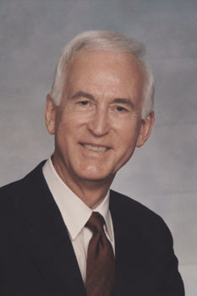  C. E. Page  United Methodist  1973 - 1977 | 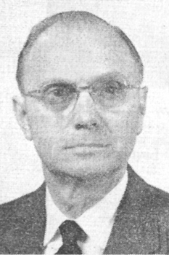  C. H. Pease  Methodist Episcopal  1934 - 1939 | 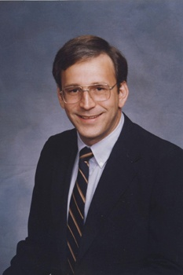  H. E. Peacock  United Methodist  1989 - 1993
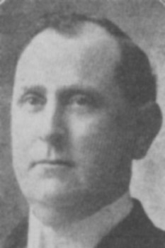  A. S. Raper  Methodist Episcopal  1906 - 1909 | 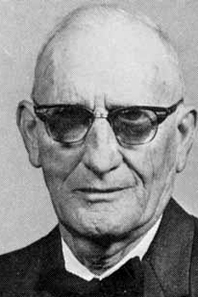  F. H. Shinn  Methodist  1944 - 1946 | 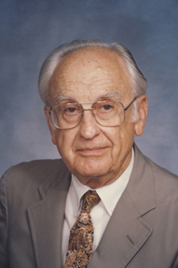  P. L. Shore  Methodist  1952 | 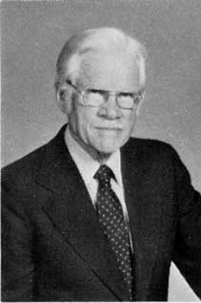  R. G. Tuttle  Methodist  1940 - 1941
